CPE301 – SPRING 2019

MIDTERM 1

Student Name: Robert Sander

Student #: 5002102412

Student Email: sander1@unlv.nevada.edu

Primary Github address: <https://github.com/sanderUNLV/submission_DA.git>

Youtube link: <https://youtu.be/nsGQEdybKag>

1. **COMPONENTS AND CONNECTIONS**

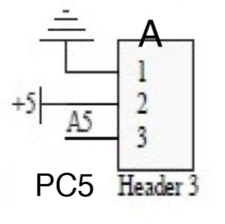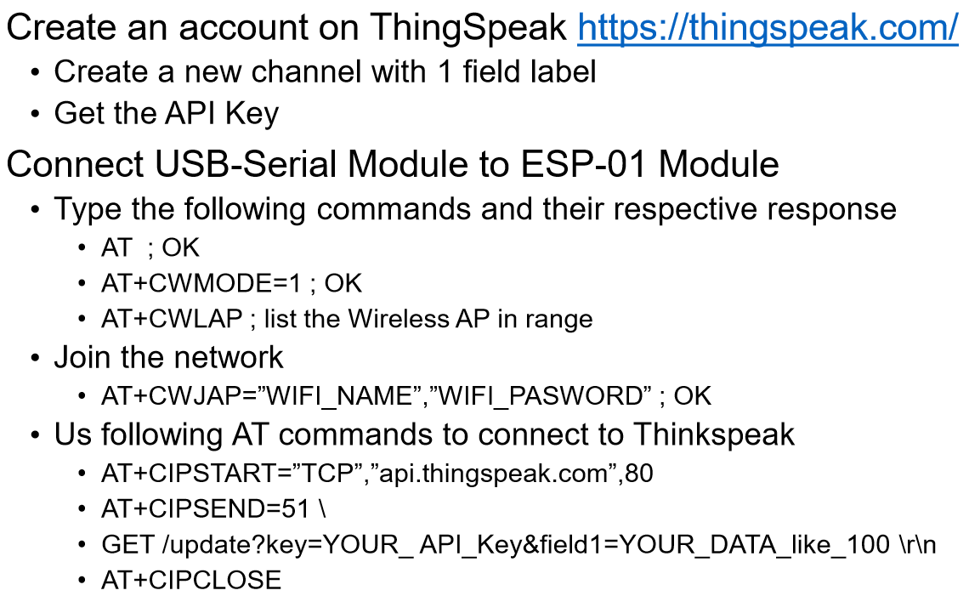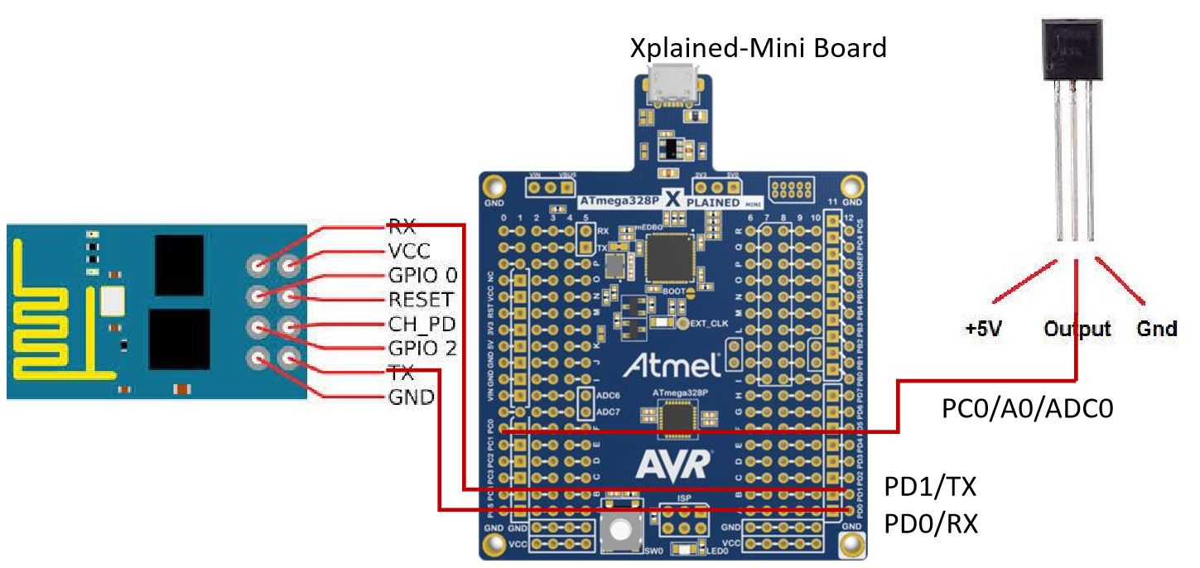

1. **INITIAL/MODIFIED/DEVELOPED CODE**

// Mid1.c

// Author : Robert Sander

#define *F_CPU* 16000000UL

#include <avr/io.h>

#include <stdio.h>

#include <avr/interrupt.h>

#include <util/delay.h>

#define BAUDRATE 9600

#define BAUD_PRESCALLER (((*F_CPU* / (BAUDRATE * 16UL))) - 1)

//Declaration of our functions

void USART_init( unsigned int ubrr);

void USART_tx_string( char *data );

void adc_init(void);

void read_adc(void);

void esp_init();

void USART_putadc();

volatile double adc_temp = 0;

char outadc[20];

int main(void) {

DDRB = 0x3C; // Set PB2.5 as input

PORTB = 0x3C; // Turn off PB LEDs on multishield

DDRC = 0; // Make Port C an input for ADC input

adc_init(); // Initialize the ADC

USART_init(BAUD_PRESCALLER); // Call the USART initialization code

esp_init(); // Initialize the esp with AT commands

while (1){

esp_init();

USART_tx_string("Temperature: ");

USART_putadc();

*_delay_ms*(17000); // Delay serial data for at least 15 seconds for thingspeak minimum

}

}

void adc_init(void)

{

// Setup and enable ADC

ADMUX = (0<<REFS1)| // Reference Selection Bits

(1<<REFS0)| // AVcc with ext cap at AREF pin

(0<<ADLAR)| // ADC Left Adjust Result

(0<<MUX3)| // Analog Channel Selection Bits

(1<<MUX2)|

(0<<MUX1)|

(1<<MUX0); // ADC5

ADCSRA = (1<<ADEN)| // ADC ENable

(1<<ADSC)| // ADC Start Conversion

(1<<ADATE)| // ADC Auto Trigger Enable

(0<<ADIF)| // No ADC Interrupt Flag

(0<<ADIE)| // No ADC Interrupt Enabled

(1<<ADPS2)|(1<<ADPS1)|(1<<ADPS0); // ADC Prescaler - 128

}

void esp_init(){

USART_tx_string("AT+CWJAP=\"ssid\",\"password\"");

USART_tx_string("AT+CIPSTART=\"TCP\",\"api.thingspeak.com\",80");

USART_tx_string("AT+CIPSEND=51");

USART_tx_string("GET /update?key=KEY&field1=100");

USART_tx_string("GET /update?key=key&field1=100");

}

void read_adc(void)

{

unsigned char i = 4;

while (i--)

{

while((ADCSRA&(1<<ADIF))==0);//wait for conversion to finish

PORTB ^= (1 << 2); // Toggle PB.2 LED every time ADIF is set, indicated adc conversion visually

adc_temp += ADC; // Put adc value in "adc_temp"

*_delay_ms*(100); // Wait a 100ms

ADCSRA |= (1<<ADIF); // Clear the flag

}

adc_temp = adc_temp / 4; // Average a 4 samples

}

void USART_init( unsigned int ubrr) {

UBRR0H = (*uint8_t*)(BAUD_PRESCALLER >> 8);

UBRR0L = (*uint8_t*)(BAUD_PRESCALLER);

UCSR0B = (1 << TXEN0);

UCSR0C = (3 << UCSZ00);

}

void USART_tx_string( char *data )

{

while ((*data != '\0'))

{

while (!(UCSR0A & (1 <<UDRE0)));

UDR0 = *data;

data++;

}

}

void USART_putadc(){

read_adc(); // initialize adc reading

*snprintf*(outadc, sizeof(outadc), "%3f\r\n", adc_temp); // print it

USART_tx_string(outadc);

}

1. **SCREENSHOT OF EACH DEMO (BOARD SETUP)**

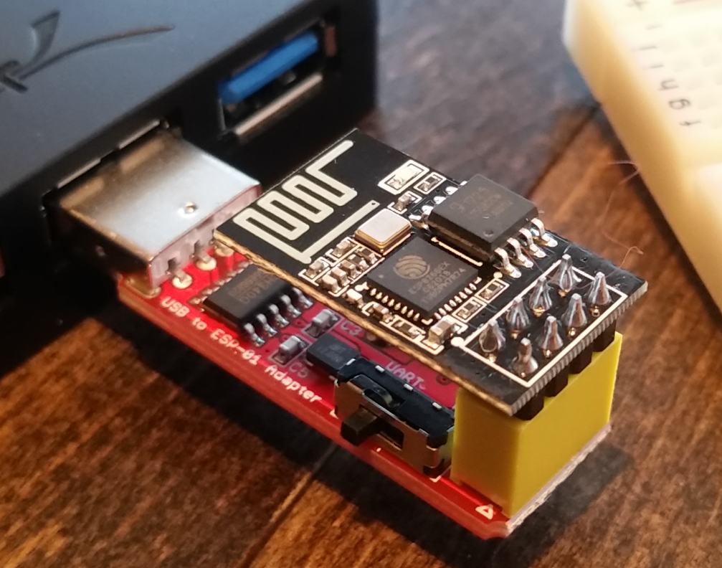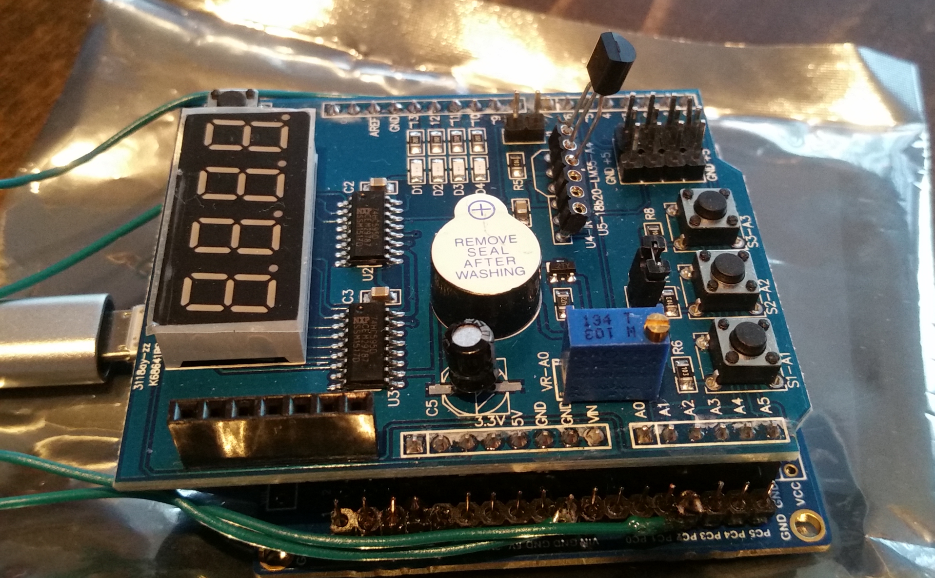

*Figure 2 – MultiShield LM35 setup*

*Figure 1 – ESP firmware setup*

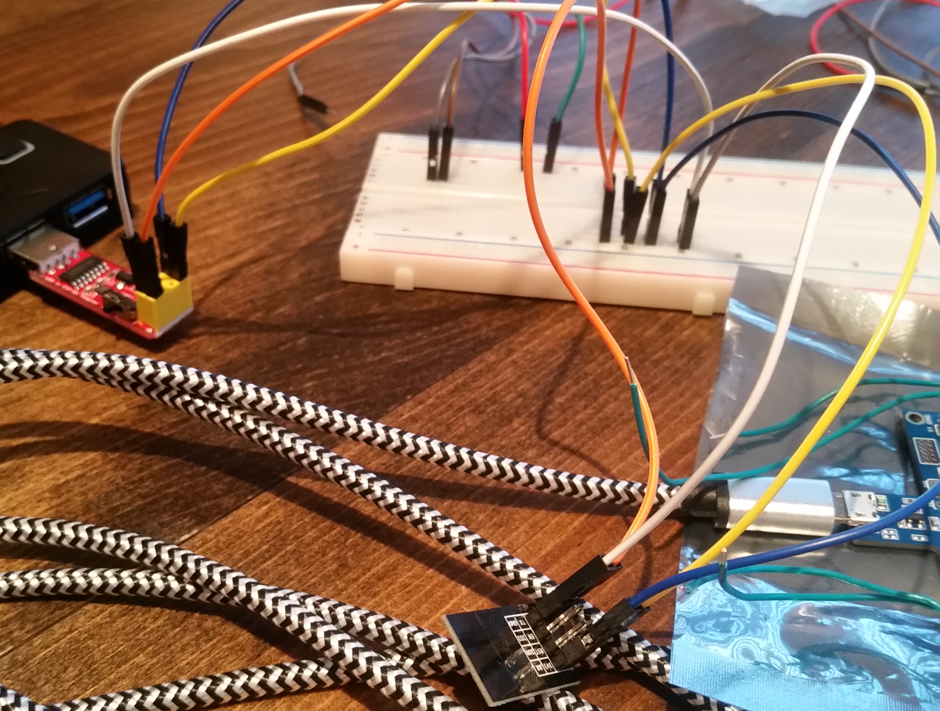

*Figure 3 – Esplorer testing setup*

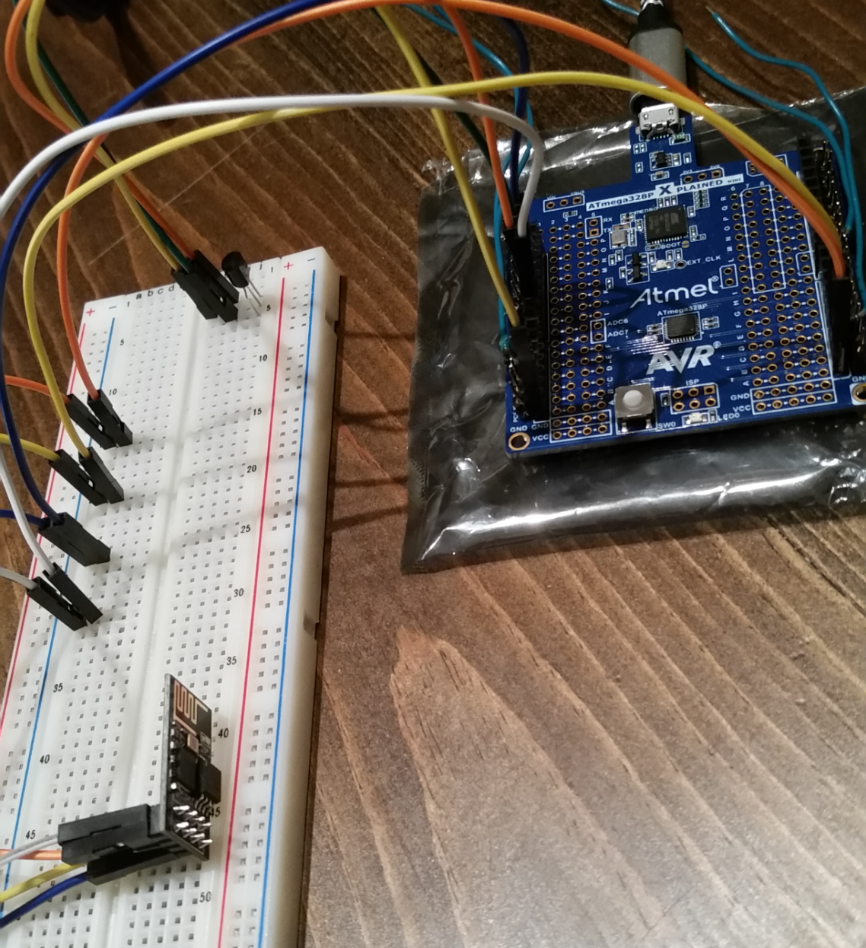

*Figure 4 – ESP, LM35, XplainedMini setup*

1. **VIDEO LINKS OF EACH DEMO**

<https://youtu.be/nsGQEdybKag>

1. **GITHUB LINK OF THIS DA**

<https://github.com/sanderUNLV/submission_DA.git>

**Student Academic Misconduct Policy**

<http://studentconduct.unlv.edu/misconduct/policy.html>

“This assignment submission is my own, original work”.

Robert Sander